Problem Statement

Rashford assoc. are having trouble provisioning their server environment because of the inconsistencies caused by the new update. They have Hired Marcus to solve their problems related to managing servers. Marcus, after researching, introduced Ansible to the system. Now, he needs to provision the production environment for the upcoming update of their software.

Action Items

• Create separate roles for setting up Apache Tomcat and Apache Maven 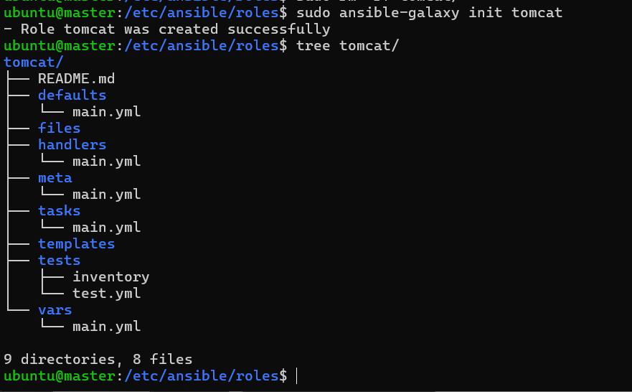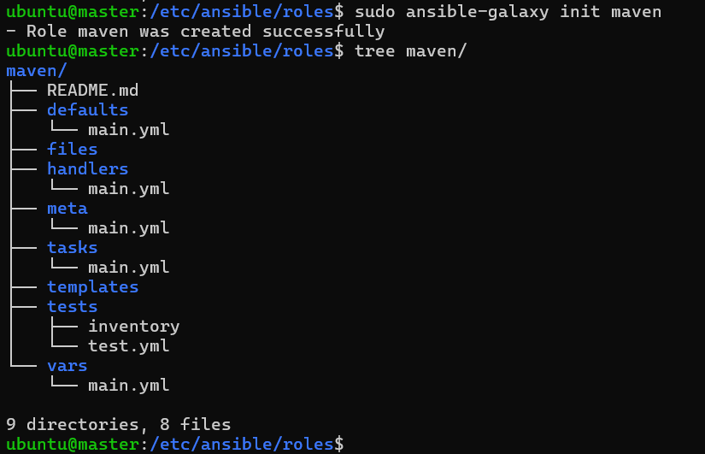

• Add the necessary logic to the roles to set up the tools

• Create a new playbook and call Tomcat as well as Maven roles inside it

• Execute the playbook on all the hosts

Commands to install Tomcat and Maven

Apache Tomcat:

1. sudo apt-get update

2. sudo apt-get install default-jdk

3. sudo groupadd tomcat

4. sudo useradd -s /bin/false -g tomcat -d /opt/tomcat tomcat

5. curl -O https://archive.apache.org/dist/tomcat/tomcat-8/v8.5.31/bin/apache-tomcat-8.5.31.tar.gz

6. sudo mkdir /opt/tomcat

7. sudo tar xzvf apache-tomcat-8*tar.gz -C /opt/tomcat --strip-components=1

8. sudo mkdir /opt/tomcat

9. cd /opt/tomcat

10. sudo chgrp -R tomcat /opt/tomcat

11. sudo chmod -R g+r conf

12. sudo chmod g+x conf

13. sudo chown -R tomcat webapps/ work/ temp/ logs/

14. Add this code to /etc/systemd/system/tomcat.service

[Unit]

Description=Apache Tomcat Web Application Container

After=network.targetd

[Service] Type=forking

Environment=JAVA_HOME=/usr/lib/jvm/java-1.8.0-openjdk-amd64/jre Environment=CATALINA_PID=/opt/tomcat/temp/tomcat.pid Environment=CATALINA_HOME=/opt/tomcat Environment=CATALINA_BASE=/opt/tomcat Environment='CATALINA_OPTS=-Xms512M -Xmx1024M -server -XX:+UseParallelGC' Environment='JAVA_OPTS=-Djava.awt.headless=true Djava.security.egd=file:/dev/./urandom'

ExecStart=/opt/tomcat/bin/startup.sh

ExecStop=/opt/tomcat/bin/shutdown.sh

User=tomcat

Group=tomcat

UMask=0007

RestartSec=10

Restart=always

[Install]

WantedBy=multi-user.target

15. sudo systemctl daemon-reload

16. sudo systemctl start tomcat

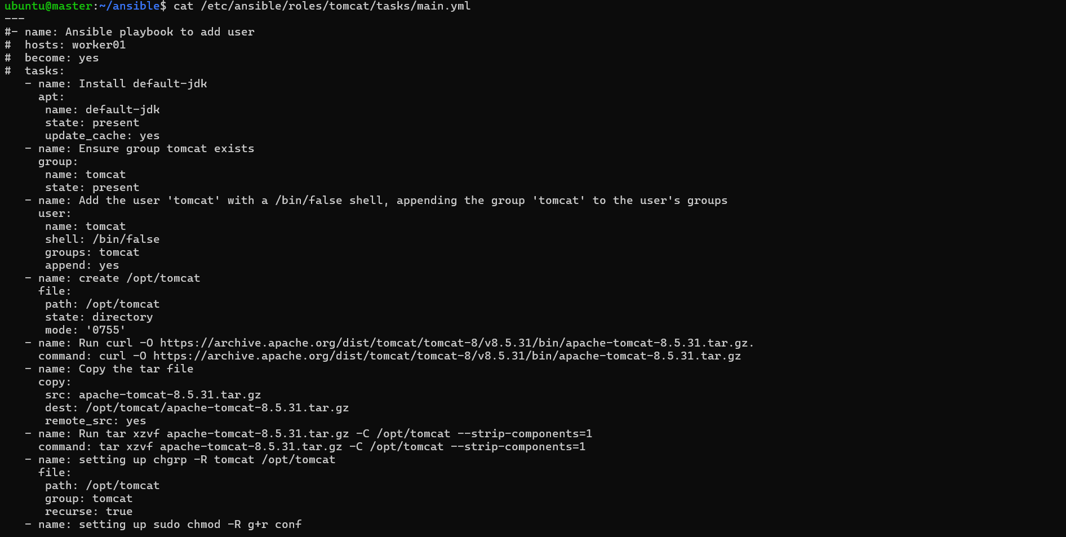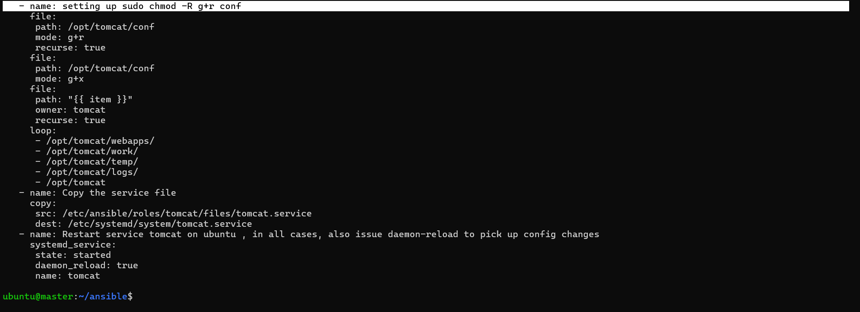

Apache Maven:

1. sudo apt install -y python-software-properties

2. sudo add-apt-repository ppa:webupd8team/java

3. sudo apt update

4. sudo apt-get install default-jdk

5. cd /home/edureka/Downloads/ && wget http://apache.mirror.digitalpacific.com.au/maven/maven-3/3.3.9/binaries/apache maven-3.3.9-bin.tar.gz

6. cd /opt/ && sudo tar -xzvf /home/edureka/Downloads/apache-maven-3.3.9-bin.tar.gz 7. sudo update-alternatives --install /usr/bin/mvn maven /opt/apache-maven 3.3.9/bin/mvn 1001

